RESOLUTION NO.__________

RE: CERTIFICATE OF APPROPRIATENESS UNDER THE
PROVISIONS OF THE ACT OF THE PENNSYLVANIA
LEGISLATURE 1961, JUNE 13, P.L. 282 (53
SECTION 8004) AND BETHLEHEM ORDINANCE NO.
3952 AS AMENDED.

WHEREAS, it is proposed to install decal signs in storefront windows at 17 E. Third St.

NOW, THEREFORE, BE IT RESOLVED by the Council of the City of Bethlehem that a Certificate of Appropriateness is hereby granted for the work.

Sponsored by: (s)

(s)

ADOPTED BY COUNCIL THIS DAY OF

(s)
President of Council

ATTEST:

(s)
City Clerk

HISTORIC CONSERVATION COMMISSION

CASE # 518 – It is proposed to install decal signs in storefront windows at 17 E. Third St.
OWNER/APPLICANT: Charles Buck / Franklin Pichardo

The Commission upon motion by Mr. Evans seconded by Mr. Lader adopted the proposal that City Council issue a Certificate of Appropriateness for the proposed work described herein:
- The proposal to install decal signs in storefront windows at 17 E. Third St. was presented by Franklin Pichardo.
- The new signs read “To’Makao Fine Cigars” in white lettering above and below an oval logo in yellow and red. The decals are located in the two front windows and are already installed.
- The rectangular carved sign located in the right display window will be removed.
- The OPEN and ATM signs must be repositioned to be 4”-6” below the vinyl sign and centered on the oval signs.
- The neon signs in the left display window may remain as installed.
- The proposed motion was unanimously approved.

CU: cu

By: 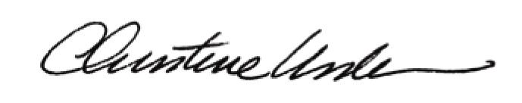

Date of Meeting: October 20, 2014 Title: Historic Officer

